- Create a Github account
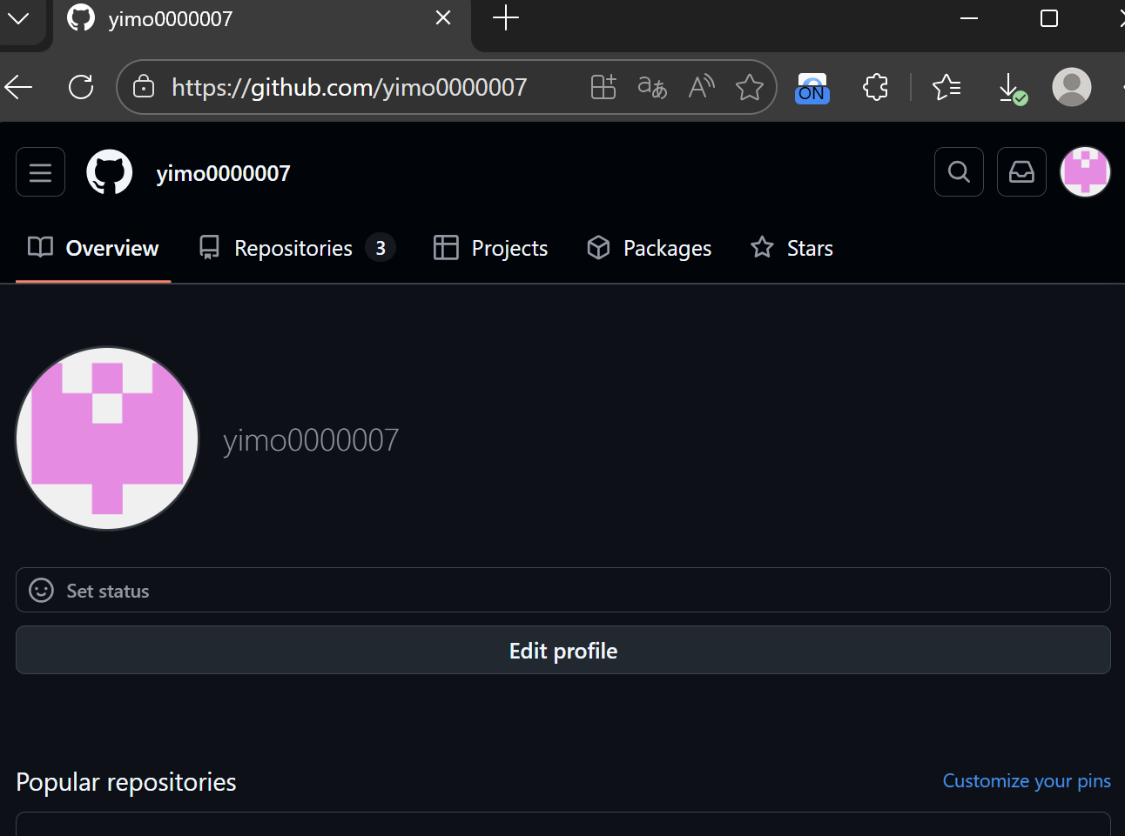
- Set up a new repository named username.github.io
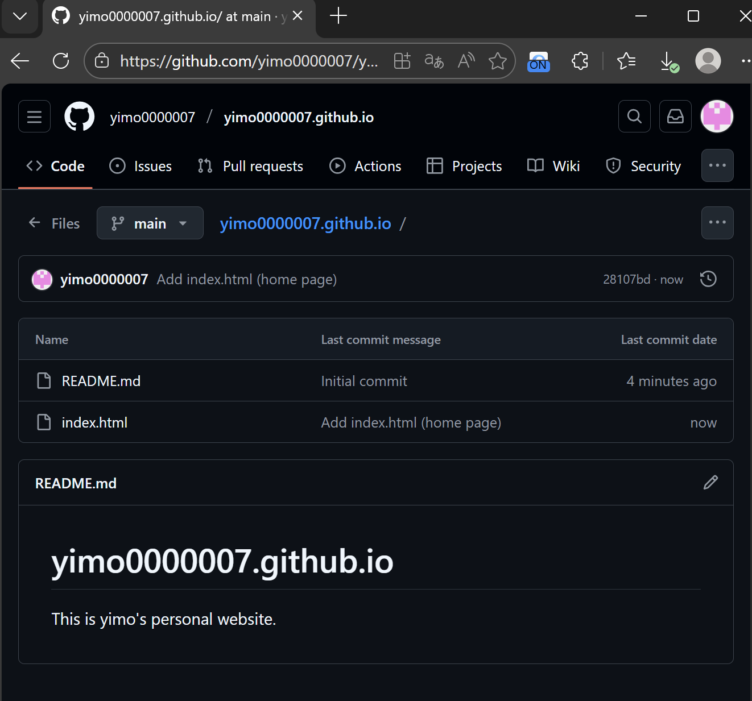

- Add at least a home page to give a brief introduction of myself.
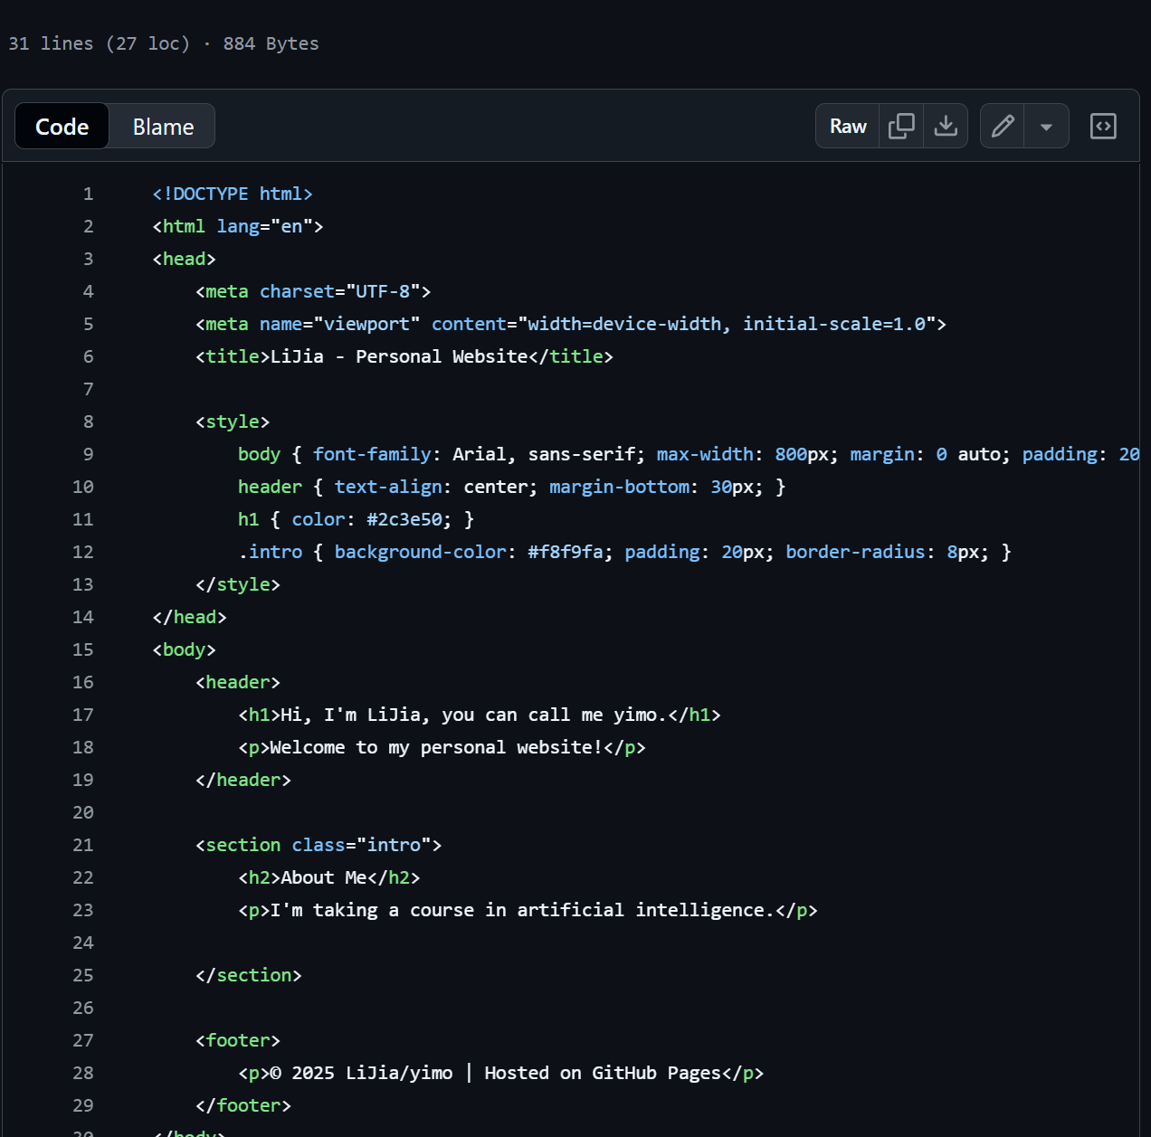
- Publish the website and verify that it is accessible
